Playing a known winning game, we can see how the pins reduce to just 1 pin. From this we can see a simple pattern for playing the game backwards. This pattern is if a pin has 2 empty hole next to it can jump its current position to fill the 2 empty holes. Or in other words if represent our empty holes with a “o” and a pinned hole as a “x” we can swap out a “oox” to a “xxo” and a “xoo” to a “oxx” whenever they appear. This creates an easy way to find all winning positions as we can just start from the only winning position which is a single “x” and play all possible backwards games.

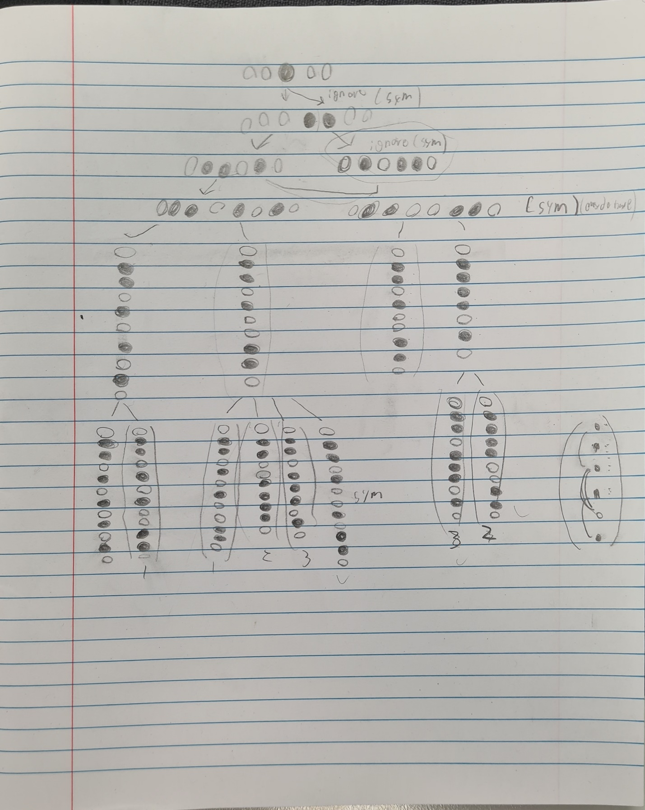

A quick hand play of playing this game in reverse starting from a winning position up to 6 layers.

As at each reverse move adds one pin this finds all possible winnable starting positions with 6 pins. We can see that when going down the tree of possible options this does lead to a significant number of mirror images of each other. However, if these are removed when a mirror image exists, we can get a list of all distinct winnable starting positions.